**Steps Covered**

1. Requirement gathering from client

2. Identify the Stakeholders of the Project

3. Data cleaning as per the requirement

4. Data Processing by adding some customized columns in data

5. Data Analysis by Pivot Tables and Excel Functions

6. Data Visualization to create charts and custom sheets to show the insights

7. Report/ Dashboard creation from start to end

**REQUIREMENT**

Clients wants to create a Road Accident Dashboard for year 2021 and 2022 so that they can have insight on the below requirements

* Primary KPI – Total Casualties taken place after the accident
* Primary KPI – Total Casualties & Percentage of total with respect to accident severity and maximum casualties by type of vehicle
* Secondary KPI’s – total Casualties with respect to vehicle type
* Monthly trend showing comparison of casualties for Current Year and Previous Year
* Maximum casualties by Road Type
* Distribution of total casualties by Road Surface
* Relation between Casualties by Area/Location & Day/Night

**STAKEHOLDERS**

* Ministry of Transport
* Road Transport Department
* Police Force
* Emergency Services Department
* Road Safety Corps
* Transport Operators
* Traffic Management Agencies
* Public
* Media

**Metadata**

* File Extension - .xlsx
* No of Rows – 3.07 Million
* No of Fields – 21

**Data Cleaning**

1. Adjusted Column Width.
2. Add Filter.
3. In ‘Accident Severity’ column, replace ‘Fetal’ with Fatal.

**Data Processing**

Added two extra column ***Month*** and ***Year*** for monthly comparison from previous year using below two formulas.

Month=TEXT(B2,"mmm")

Year=TEXT(B2,'yyyy")

**After Data Analysis and Data Visualization. Below is the Dashboard**

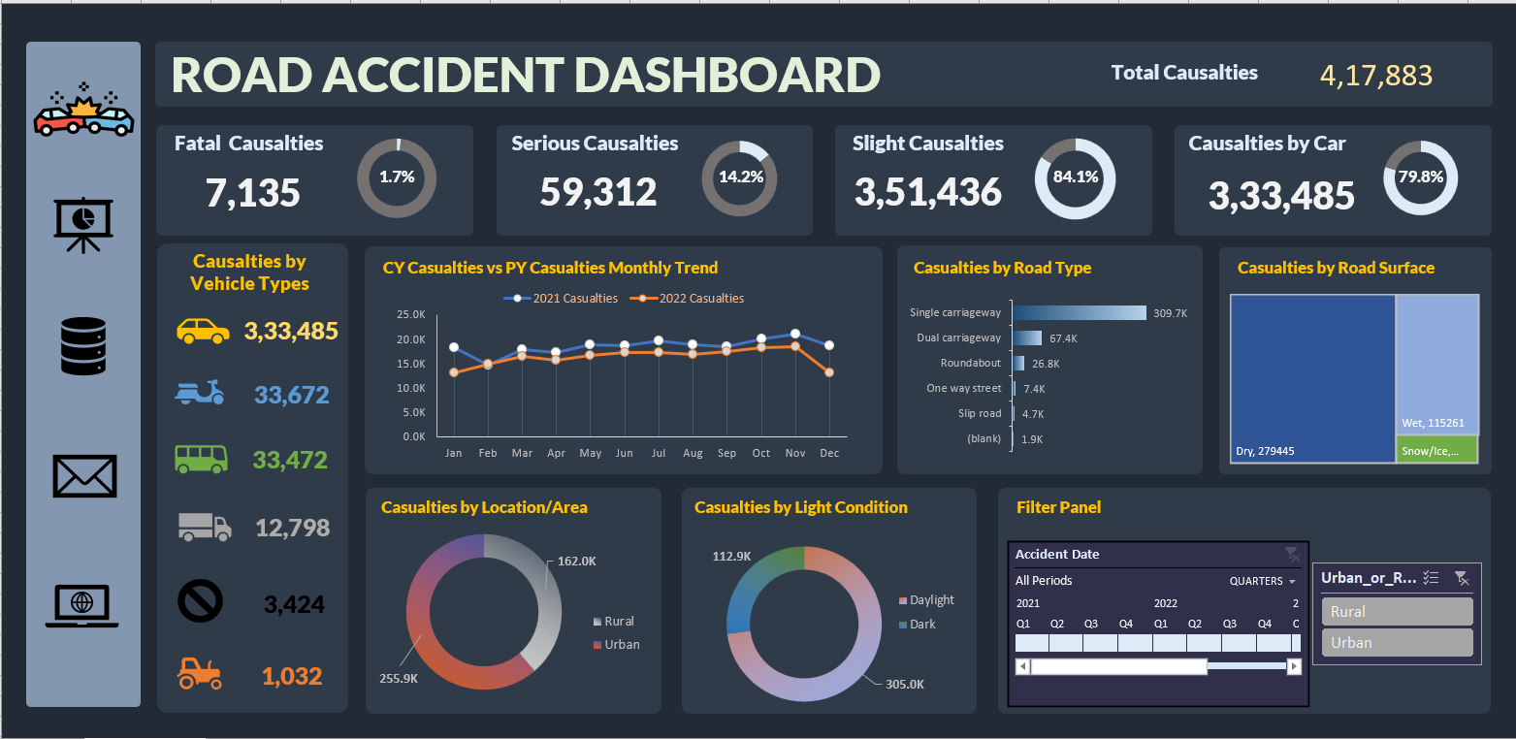

### Conclusions:

1. What are the most common types of vehicles involved in accidents?

The most common types of vehicles involved in accidents are cars, vans or goods vehicles under and over 3.5 tonnes and 7.5 tonnes and motorcycles over 500cc.

* Among these vehicles, cars are involved in maximum accident by a significant margin.
* Interestingly, motorcycles are the second most common type of vehicle involved in accidents, even though they are less frequently seen on the roads compared to cars and vans. This suggest that motorcycles are particularly vulnerable to accidents and may required additional safety measures to prevent accidents from occurring.

1. How do the number of casualties vary across different road types?
   * The results suggest that single carriageway accidents are the most dangerous and result in the highest number of casualties. After that Dual carriageway and roundabout road types contributes the most while slip road accidents are the least dangerous.

### Recommendations:

Based on the above conclusions, here are some recommendations to improve road safety:

1. Encourage additional safety measures for motorcycles: Given that motorcycles are the second most common type of vehicle involved in accidents, it may be worthwhile to explore additional safety measures such as improving road infrastructure, mandatory helmet use, or better education for motorcycle riders.
2. Focus on improving driving in fine weather conditions: As the majority of accidents occur during fine weather conditions, it may be worthwhile to explore ways to improve driver education and awareness during such conditions to help reduce the number of accidents.
3. Increase public transportation options. It could help reduce the number of accidents by reducing the number of vehicles on the road.

Overall, improving road safety requires a multi-faceted approach that involves education, infrastructure, and policy changes. These recommendations are a starting point for improving road safety and should be further explored.